9.22: a) 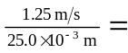50.0 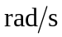, 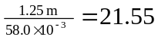, or 21.6 to three figures.

b) (1.25 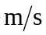) (74.0 min) (60 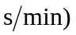= 5.55 km.

c) 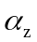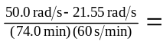 6.41